JavaScript Datatype

Datatype in JavaScript are different from traditional programming languages.

You don’t have to specify data type while declaring a variable.

**Variables, Constant and Scoping**

Variables act as container of datatypes . Variable in js can be container of single value like a number, a string or represent a object or even a group of object or even a function.

Variable in js can be declared by using 3 keywords

1. **var(default)**

var x=5;

**2.let**

let x=5;

**3.const**

const x= 5;

You can change the value of variable declared using *var* or *let*  but you can’t do that with const variable.

**Implementation:**

var x=5;

x='naomi';

// output x

'naomi'

let x=5;

x='naomi';

//output x

'naomi'

const x= 5;

x='naomi'

Error: Uncaught TypeError: Assignment to constant variable.

at <anonymous>:1:2

**Variable Block Scoping(**var vs let**)**

1. **var(Block level Global)**

function varTest() {

    var x = 1;

**{**

      var x = 2;  // same variable!

      console.log(x);  // 2

**}**

    console.log(x);  // 2

  }

console.log(x);

'Uncaught ReferenceError: x is not defined'

The **var statement** declares a **globally-scoped** means **function-scoped** variable.

1. **let(Block Level local)**

function letTest() {

    let x = 1;

**{**

      let x = 2;  // different variable

      console.log(x);  // 2

**}**

    console.log(x);  // 1

  }

console.log(x); //

'Uncaught ReferenceError: x is not defined'

The **let** statement declares a block-scoped **local variable**.

**Here global and local are relative to block.**

**Chameleon Datatypes**

Experiment with variable x

let x;

typeof(x)

'undefined'

x=1;

typeof(x)

'number'

x='a';

'a'

typeof(x)

'string'

x=1.23;

1.23

typeof(x)

'number'

x=true;

true

typeof(x)

'boolean'

x={a:1,b:1}

{a: 1, b: 1}

typeof(x)

'object'

x=null;

null

typeof(x)

'object'

Datatype of variable in JavaScript have chameleon like properties which means they don’t have fixed data types.

There are two types of datatypes in JavaScript.

1. **Non-Object Datatypes (Primitive)**
2. **Object Datatypes (Non Primitive)**

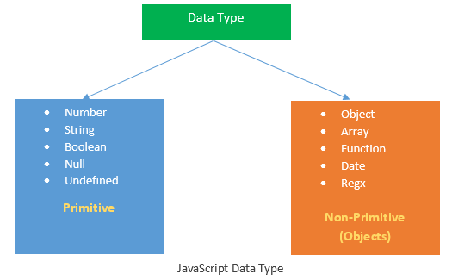

Date and regex(regular expressions) are **Global objects** in JS.

Some more experiments

let x = function(){}

typeof(x)

'function'

x= new Date();

Wed Jan 26 2022 22:05:31 GMT+0530 (India Standard Time)

typeof(x)

'object'

x=new RegExp('ab+c');

typeof(x)

'object'